

**Title:**

**Diabetic Retinopathy Detection Using Convolutional Neural Networks**

**A CORE COURSE PROJECT REPORT**

**Submitted By**

**YAAZHINI A HEMALATHA M**

**REG NO. 23CS252 REG NO. 23CS067**

**in partial fulfillment for the award of the degree of**

**BACHELOR OF ENGINEERING**

**IN**

**COMPUTER SCIENCE AND ENGINEERING**



**DEPARTMENT OF COMPUTER SCIENCE AND ENGINEERING**

**CHENNAI INSTITUTE OF TECHNOLOGY**

**(Autonomous)**

Sarathy Nagar, Kundrathur, Chennai-600069

**OCT / NOV – 2024**



**Vision of the Institute:**

To be an eminent centre for Academia, Industry and Research by imparting knowledge, relevant practices and inculcating human values to address global challenges through novelty and sustainability.

**Mission of the Institute:**

**IM1**.To creates next generation leaders by effective teaching learning methodologies and instill scientific spark in them to meet the global challenges.

**IM2**.To transform lives through deployment of emerging technology, novelty and sustainability.

**IM3**.To inculcate human values and ethical principles to cater the societal needs.

**IM4**.To contributes towards the research ecosystem by providing a suitable, effective platform for interaction between industry, academia and R & D establishments.

**IM5**.To nurture incubation centres enabling structured entrepreneurship and start-ups.



**DEPARTMENT OF**

**COMPUTER SCIENCE AND ENGINEERING**

**Vision of the Department**:

To Excel in the emerging areas of Computer Science and Engineering by imparting knowledge, relevant practices and inculcating human values to transform the students as potential resources to contribute innovatively through advanced computing in real time situations.

**Mission of the Department**:

**DM1.** To provide strong fundamentals and technical skills for Computer Science applications through effective teaching learning methodologies.

**DM2.** To transform lives of the students by nurturing ethical values, creativity and novelty to become Entrepreneurs and establish start-ups.

**DM3.** To habituate the students to focus on sustainable solutions to improve the quality of life and the welfare of the society.



**CERTIFICATE**

This is to certify that the “**Core Course Project**” Submitted by **Yaazhini A(Reg no:23CS252), Hemalatha M(Reg no: 23CS252)** is a work done by him/her and submitted during **2024-2025** academic year, in partial fulfilment of the requirements for the award of the degree of **BACHELOR OF ENGINEERING** in **DEPARTMENT OF COMPUTER SCIENCE AND ENGINEERING**, at Chennai Institute of Technology.

|  |  |
| --- | --- |
| **Project Coordinator**  (Name and Designation) | **Internal Examiner** |
| **Head of the Department**  (Name and Designation) | **External Examiner** |

**ACKNOWLEDGEMENT**

We express our gratitude to our Chairman **Shri.P.SRIRAM** and all trust members of Chennai institute of technology for providing the facility and opportunity to do this project as a part of our undergraduate course.

We are grateful to our Principal **Dr.A.RAMESH M.E**, **Ph.D.** for providing us the facility and encouragement during the course of our work.

We sincerely thank our Head of the Department **Dr.S.Pavithra,** Department of Computer Science and Engineering for having provided us valuable guidance, resources and timely suggestions throughout our work.

We would like to extend our thanks to ourProject Co-ordinator of the **Dr. R. Ponnusamy,** Department of Computer Science and Engineering, for his valuable suggestions throughout this project.

We wish to extend our sincere thanks to allFaculty members of the Department of Computer Science and Engineering for their valuable suggestions and their kind cooperation for the successful completion of our project.

We wish to acknowledge the help received from the **Lab Instructors of the** Department of Computer Science and Engineering and others for providing valuable suggestions and for the successful completion of the project.

**NAME:** YAAZHINI A **REG.NO:** 23CS252

HEMALATHA M 23CS067

**PREFACE**

I, a student in the Department of Computer Science and Engineering need to undertake a project to expand my knowledge. The main goal of my Core Course Project is to acquaint me with the practical application of the theoretical concepts I’ve learned during my course.

It was a valuable opportunity to closely compare theoretical concepts with real-world applications. This report may depict deficiencies on my part but still it is an account of my effort.

The results of my analysis are presented in the form of an industrial Project, and the report provides a detailed account of the sequence of these findings. This report is my Core Course Project, developed as part of my 2nd year project. As an engineer, it is my responsibility to contribute to society by applying my knowledge to create innovative solutions that address their changes.

**TITLE PAGE**

**Title:**

Diabetic Retinopathy Detection using Convolutional Neural Networks (CNNs)

**Author 1:**

Ponnusamy P

**Author 2:**

Yaazhini A

**Author 3:**

Hemalatha M

**College Name:**

Chennai Institute of Technology

**DECLARATION**

I, Yaazhini A and Hemalatha M, hereby declare that the project report entitled “**Diabetic Retinopathy Detection Using Convolutional Neural Networks (CNNs)**”, submitted in partial fulfillment of the requirements for the degree of Bachelor of Technology in Computer Science and Engineering, is our original work carried out under the guidance of Dr.R.P.Ponnusamy at the Department of Computer Science and Engineering, Chennai Institute of Technology. I confirm that this work has not been submitted elsewhere for the award of any degree, diploma, or certificate.

I certify that the work contained in this report is a result of our own research and efforts. All sources of information and references used have been properly acknowledged and cited. I assure that no part of this report has been copied from any other source and that the project has not been submitted or published for any other academic or non-academic purposes. I take full responsibility for the originality and authenticity of this work.

I fully understand the consequences of plagiarism and declare that this project report, “**Diabetic Retinopathy Detection Using Convolutional Neural Networks (CNNs)**”, represents my original contribution to the academic field.

**ABSTRACT**

Diabetic retinopathy (DR) is a serious eye condition affecting individuals with long-term diabetes, leading to potential blindness if not detected and treated early. Traditional diagnostic methods rely heavily on manual examination of retinal fundus images by trained ophthalmologists, a process that is time-consuming and prone to human error. With the increasing prevalence of diabetes worldwide, there is a growing need for automated, accurate, and efficient detection systems to assist in diagnosing diabetic retinopathy in its early stages.This project presents the development of a deep learning model using Convolutional Neural Networks (CNNs) to classify retinal fundus images into different stages of diabetic retinopathy, ranging from no DR to proliferative DR. The proposed model is trained on a publicly available dataset of retinal images and is designed to automatically extract features from these images to detect abnormalities. The CNN-based approach shows promising results, with a classification accuracy of 83.5%, demonstrating its potential to serve as a valuable tool for early detection and treatment planning in clinical settings.The research also evaluates the performance of the CNN model using various metrics such as precision, recall, and F1-score. The outcomes are compared with existing methods for DR detection, highlighting the effectiveness and efficiency of CNNs in automating the diagnosis process. By reducing the burden on healthcare professionals and improving diagnostic accuracy, this model can significantly contribute to preventing vision loss in diabetic patients.

**CONTENTS**

**LIST OF FIGURES ……………………………………………………………**

**LIST OF TABLES …………………………………………………………….**

**LIST OF ABBREVIATIONS ……………………………………………………**

**CHAPTER 1: INTRODUCTION…………………………………………….**

* 1. Background of Study……………………………………………………
  2. Research Problem…………………………………………………..
  3. Research Questions/Objectives…………………………………….
  4. Significance of the Study ……………………………………………
  5. Scope of the Study ………………………………………………..
  6. Thesis Organisation ……………………………………………….

**CHAPTER 2: LITERATURE REVIEW ……………………………………**

2.1 Diabetic Retinopathy (DR) …………………………………………..  
 2.2 The Effects of Diabetic Retinopathy (DR) …………………………….

2.3 Microaneurysms (MA) .......................................................................... (6)  
2.4 Need for Automatic Detection of DR......................................................... (7)  
2.5 Review of Previous Work ........................................................................ (8)  
2.6 Gaps in the Literature .............................................................................. (9)  
2.7 Theoretical Foundations ........................................................................ (10)

**CHAPTER 3: METHODOLOGY …………………………………………….**

3.1 Research Design (Architecture / Framework) ......................................... (11)  
3.2 Data Collection Methods ......................................................................... (12)  
3.3 Pre-Processing Stage (PPS) ................................................................... (13)  
3.3.1 Color Fundus Image ............................................................................. (14)  
3.3.2 Cropped Image .................................................................................... (15)  
3.3.3 Grayscale Image ................................................................................. (15)  
3.3.4 Binary Image ....................................................................................... (16)  
3.4 Feature Extraction .................................................................................... (17)  
3.5 Classification ......................................................................................... (18)  
3.6 Algorithm / Procedure / Pseudo Code ................................................................ (19)  
3.7 Software and Tools Used .................................................................................... (20)

**CHAPTER 4: RESULTS AND FINDINGS ……………………………**

4.1 Presentation of Data/Results .............................................................................. (22)  
4.2 Tables, Charts, or Graphs for Clarity .................................................................. (24)  
4.3 Analysis of Findings .......................................................................................... (26)

**CHAPTER 5: DISCUSSION ……………………………………………**

5.1 Interpretation of the Findings ......................................................................... (30)  
5.2 Comparison with Previous Research .................................................................. (32)  
5.3 Implications of the Study .................................................................................... (34)  
5.4 Limitations of the Research ................................................................................ (36)

**CHAPTER 6: CONCLUSION AND FUTURE WORK ………………**

6.1 Conclusion ........................................................................................................... (39)  
6.2 Recommendations for Future Research ............................................................. (40)  
6.3 Practical Implications of the Results ................................................................. (40)

**LIST OF FIGURES**

**Fig. 2.1**: Cross-sectional view of the human eye.  
**Fig. 2.1.1**: Anatomy of the eye.  
**Fig. 2.1.2**: Normal retinal image.  
**Fig. 2.1.3**: Exudate retinal image.  
**Fig. 2.1.4**: Haemorrhage image.  
**Fig. 2.3**: Retinal image with microaneurysm.  
**Fig. 3.1**: Basic design of the CNN architecture.  
**Fig. 3.2**: Flow chart of pre-processing.  
**Fig. 3.2.1**: Fundus image.  
**Fig. 3.2.2**: Cropped image.  
**Fig. 3.2.3**: Grayscale image.  
**Fig. 3.2.4**: Binary image.  
**Fig. 4.1**: GUI supported by MATLAB.  
**Fig. 4.1.1**: Main GUI window.  
**Fig. 4.1.2**: GUI window with selected input image.  
**Fig. 4.1.3**: GUI window after processing.  
**Fig. 5.1.1 (a)**: Performance plot of Normal DR.  
**Fig. 5.1.1 (b)**: Performance plot of Exudate.  
**Fig. 5.1.1 (c)**: Performance plot of Haemorrhages.

**LIST OF TABLES**

**Table 4.2.1**: Results for normal images.  
**Table 4.2.2**: Results for abnormal images.

**LIST OF ABBREVIATIONS**

1. **DR**: Diabetic Retinopathy
2. **CNN**: Convolutional Neural Network
3. **NPDR**: Non-proliferative Diabetic Retinopathy
4. **PDR**: Proliferative Diabetic Retinopathy
5. **MSE**: Mean Square Error
6. **RGB**: Red Green Blue (color format)
7. **MA**: Microaneurysms
8. **PPS**: Pre-processing Stage

|  |
| --- |
| **CHAPTER 1:**  **INRODUCTION** |

**1.1 Background of the study**

It is one of the most common forms of serious microvascular complications of diabetes mellitus, capable of resulting in a variety of impairments in vision to complete blindness if not treated and identified early. The burden of DR also increases with the alarming rate at which the incidence of diabetes is on the increase all over the world. The condition is characterized by the progressive destruction of the blood vessels in the retina, and this has become one of the major causes of blindness, especially in the working age. This prevalence problem is further compounded by the fact that patients with long-standing diabetes have a high propensity to develop DR.  
  
DR characteristically progresses through two stages: Non-Proliferative Diabetic Retinopathy (NPDR) and Proliferative Diabetic Retinopathy (PDR). NPDR is the earliest stage, where the blood vessels in the retina start weakening, giving rise to microaneurysms, hemorrhages, and fluid leakage into the retina. NPDR will progress left untreated to the PDR, which is an advanced condition with a wide abnormal growth of new blood vessels on the surface of the retina, a process termed neovascularization. This is delicate and likely to bleed, causing devastating loss of vision or even blindness. Since each stage of DR is characterized by the specific challenges posed to early diagnosis and intervention, the timely detection of this condition is important to avoid chances of permanent changes.  
  
While much attention has been raised that revolves around DR because of its high stakes, there is not much success in the early detection and intervention in many healthcare systems worldwide. A comprehensive eye examination with retinal images or fundus photography taken by specialized equipment is the present main method of diagnosing DR. These images are then reviewed by trained ophthalmologists or retina specialists who manually examine them for signs of DR, such as microaneurysms, hemorrhages, and other abnormal features. However, this process is labor-intensive, time-consuming, and very much dependent on the availability of skilled specialists.  
  
The growing demand for diabetic eye care services is already putting a significant burden on the health care systems around the world. The problem is worse in the low- and middle-income countries since the demand for professional ophthalmologists is on the rise, and there are few trained specialists to handle this. Patients often present at stages later than they should because the risk of DR progression into further advanced stages boosts enormously before appropriate interventions can Sbe administered. Thus, innovative solutions, ones that can scale to adequately screen DR quickly and accurately due to the growing diabetic population with limited availability of trained eye care professionals, come at this time of great need.  
  
This work was designed to address the urgent gap in the early detection of diabetic retinopathy by overcoming the general application challenges and specialization of AI, deep learning. CNNs are deep learning algorithms, one of the branches of the algorithms being specifically designed for processing images. There is a lot of promise of CNNs in medical imaging applications. Specifically in retinal fundus images, CNNs are specially tailored for automatic feature extraction learnt directly from images, without hand-crafted feature engineering. This makes it ideally suited for the detection of even very minute changes in the retinal structures possibly indicating DR.  
  
The manuscript put forward next proposes a deep CNN-based approach for the automation of DR detection from retinal images. The aim of this work is towards developing a machine learning model that can provide high precision for analysis of the retinal images and significantly reduce their reliance on human experts with a more efficient implementation of DR screening programs. The overall objective of this work is the development of a deep learning model capable of classifying fundus photographs of the retina into various grades of DR, such as normal, NPDR, and PDR. This model also helped improve the diagnostic accuracy and would also make large-scale screening programs possible. This can benefit under-served areas hugely by getting them fewer service professionals.  
The earlier diagnosis and appropriate treatment of DR could thus be achieved much earlier with automated detection using CNNs.  
This is of course more vital for preventing final vision loss as treatment can always be done much earlier and in time. Early intervention can halt or slow progression in DR if it is diagnosed early, possibly with laser therapy or anti-VEGF injections. Moreover, there would be relief to the workload of ophthalmologists since they can concentrate their efforts on more complex cases or on treatment to those already diagnosed to have advanced DR.  
  
Summary In summary, diabetic retinopathy constitutes major public health challenges against the backdrop of the growing prevalence of diabetes globally. Traditional methods for the identification of DR are based on manual interpretation of retinal images by experts, and therefore the system is not efficient enough to meet the increasing demand of screening and diagnosis. This study would be strengthened by adding the strength of CNN and AI capabilities in automatically detecting DR, thereby offering an efficient and scalable solution to one of the most pressing issues in diabetic eye care. It has the potential to revolutionize the field in the diagnosis and management of DR through its deep learning model in DR detection, thus altering the course of millions of diabetic patients worldwide.

**1.2 Research Problem**

Much has been achieved in medical technology over the past decades, but early detection of diabetic retinopathy still forms one of the major challenges. DR is a condition that calls for timely intervention to avoid severe complications, including permanent loss of vision. However, the detection and diagnosis of DR still have to depend on both manual assessment by an ophthalmologist or retina specialist where retinal images, that is, fundus photography, are carefully inspected for signs of the disease. This process remains labor-intensive and, more importantly, very dependent on the clinician's subjective judgment and experience, which brings variability in the diagnosis.  
  
At present, complete reliance on human assessment hampers the present screening and diagnosis protocols with several critical limitations. Firstly, checking retinal images manually is too time consuming. To have a good examination of each retinal image requires careful study; indeed, even minute signs of DR, such as microaneurysms, hemorrhages, or exudates may go unnoticed easily, especially at the very outset of the disease. A process of this scale involving a manual means would necessitate screening a large volume of diabetic patients. This results in slow and ineffective processes. In most developing regions, the demand for eye care far outweighs the supply of trained professionals. A long wait for the patient and also extensive delays in diagnosis occurs.  
  
This delay in diagnosis is problematic due to the fact that DR progresses through distinct stages, each with distinct issues. In the very early stages of NPDR, the signs may be minimal or even completely asymptomatic and thereby easy to miss unless on careful examination. By the time the disease advances to PDR, there is a higher danger of losing greater vision acuity to complete blindness. By the time most of the patients are diagnosed, the disease would have progressed to a more advanced stage when treatment is minimal and prognosis not so good.  
  
The third problem with the manual evaluation of retinal images is that the results vary, with a differential level of accuracy in diagnostics. Because of clinician reliance on their experience, training, and familiarity with subtle signs of DR, the accuracy of diagnosis varies a lot. Even expert ophthalmologists are sometimes likely to miss early manifestations of the disease, especially when faced with an overwhelming volume of images to go through. Also, the same clinicians may interpret the same retinal image differently, which may cause inconsistency in diagnosis. This variability highlights the importance of having a more standardized, objective, and reproducible diagnosis for DR, independent of the several limitations of human judgment.  
  
Moreover, worldwide, there is an acute shortage of trained ophthalmologists in lowresource settings who can conduct regular screenings for DR. The increase in the prevalence of diabetes increases the demand for diabetic eye care services, thereby putting an increased strain on over-burdened health delivery systems. This gap in the demand for DR screenings and the availability of qualified specialists is also a critical bottleneck in the early detection of the disease and its treatment thus leading to a propensity of preventable cases of vision loss.  
  
The need to overcome these limitations thus calls for the development of more efficient and reliable automated detection methods for improving speed and quality in the DR screening program. One promising field that has just started to gain momentum is artificial intelligence or, more specifically, deep learning-Convolutional Neural Networks (CNNs). This is, of course, because CNNs have been constructed with the understanding of analyzing patterns within images, exactly what would be needed for DR image classification. In contrast to human doctors, CNNs can process large volumes of retinal images rapidly and uniformly without interference from fatigue or cognitive bias.  
  
The approach of this study introduces a proposed method to overcome the deficiencies in the manual procedure of DR detection by developing an automatically trainable CNN-based system that classifies the retinal fundus images into various stages of DR. This introduced CNN model is learned so as to reduce the knowledge-based limitations such as human error while detecting DR, as it automatically identified the selected features that express microaneurysms, hemorrhages, and neovascularization. This can be automatically done by the model, allowing it to make diagnoses much quicker and more accurately in order to facilitate earlier intervention and treatment.  
  
One of the significant benefits of using a CNN-based model in DR detection is direct learning from data. The CNN learns to identify key features for DR classification instead of relying on predefined rules or handcrafted features during training on a labeled dataset of retinal images. With increased exposure to data, the model improved its ability to distinguish between normal and abnormal retinal images as well as different stages of DR. Such an ability to learn from data and improve over time makes the CNNs an effective tool to address the variability and subjectivity inherently present in human diagnosis.  
In addition, the CNN-based model could potentially increase the throughput of DR screening programs significantly. This process of automation in image analysis will allow the model to screen large patient populations rapidly, identify who needs further evaluation or treatment by a specialist, and thus alleviate the bottleneck present within the current system. There is a lack of ophthalmologists, even in regions with limited access to specialized care. This therefore ensures that with the CNN model, the reliability of the diagnosis given to patients is not affected by the volume of images processed.  
  
The objective of the research is to determine how well the proposed CNN model performs by comparing it with the standard diagnostic methods presently in use in clinical settings. It is also aimed at assessing whether the system based on the CNN could bring something meaningful into real-life healthcare as a means of enhancing the diagnosis and, consequently, the management of diabetic retinopathy by comparing the accuracy, sensitivity, and specificity of the CNN model with that of the manual screening by trained ophthalmologists.  
  
In conclusion, many areas of health care have improved through advances in medical technology, but the early detection of diabetic retinopathy is still a very significant challenge because its diagnostic task depends on human assessment and all associated time, variability, and availability limitations of specialists. The novel CNN-based model presents a solution, and in turn, can be considered as an innovative approach that may improve the efficiency, accuracy, and scalability of DR screening programs to lead to better patient outcomes while at the same time relieving the burden of vision loss caused by diabetic retinopathy.

**1.3 Research Questions/Objectives**

This study shall target the development of coming up with a CNN model for automatic detection of diabetic retinopathy in the retinal images. From this perspective, a number of research questions have been developed to facilitate further investigation: What are some features in the retinal images that depict diabetic retinopathy? How do CNNs learn to find the features appropriately?

What level of accuracy does it achieve in categorizing different phases of DR compared to standard clinical diagnostic procedures?

The research aims to provide a sound basis for the detection of DR with the help of automation and valuable insights into what deep learning capacities can do in medical images. Besides these points, the paper also explores how the technology might be integrated into current clinical practices and whether the new approach is effective and practical.

**1.4 Importance of the Study:**

This research is positioning itself to make many changes in diabetic retinopathy screening and treatment in the future. The study addresses the critical gap that exists currently in the diagnosis methods, which is the retinal images of patients using automatic detection made through CNNs, identifying DR signs. CNNs are deep algorithms used for image recognition applications.  
  
The integration of CNNs in the process of DR screening may significantly enhance the efficiency and accuracy of diagnosis. Contrasting with this, DR detection through traditional methods involves the examination of ophthalmologists, which is highly time consuming and prone to variation due to human error. Processing large amounts of data almost instantaneously, CNNs are able to detect even the slightest indicators for DR, which often remain undetected by the naked eye. This new technology ensures that more patients receive accurate diagnoses within a much shorter time frame, thus allowing for timely intervention.  
  
Early detection of DR is pivotal because it ensures prompt treatment can significantly reduce the risks of losing vision in diabetic patients. As the disease is caught in its early stages, health care providers are able to employ treatment plans to prevent DR progression and thus save the vision and quality of life of the patient. This makes this area of research pertinent to having significant impact on public health, especially with the rising incidence of diabetes worldwide.  
  
Such work is a testament to what seems to be an ever more prominent role of artificial intelligence in medicine. Actually, successful application of CNNs in the detection of DR to exemplify how AI might be harnessed to attack what otherwise seems like a very challenging and complex medical challenge might present working prospects in healthcare systems with higher diagnostic accuracy, streamlined workflows, and eventually better patient outcomes. This study not only contributes to knowledge in ophthalmology but also sets a precedent for the use of AI in diagnosis and management of other medical conditions.  
  
This study goes far beyond diabetic retinopathy. The methodologies and new technologies developed here are easily adaptable to other medicine areas, and AI-driven diagnostic tools are sure to become a standard component of clinical practice. This might result in more personalized and better-precision medical care, where AI assist the healthcare providers in making the right decisions based on comprehensive data analysis.  
  
Given the alarming increases in diabetes globally, the efficacy and reliability of DR screening approaches are more critical now than ever. This study addressed this critical call for improvement through scaling up for use in diversified healthcare setups, from specialized clinics to general primary delivery points. Improved access to accurate DR screening can help in saving the world from the extensive burden of complications from diabetes that diabetes assumes as part of the healthcare system.  
  
The research also has important implications on the economic factors. Detection as well as intervention in an early stage could also reduce the rate of occurrence of severe DR, thus saving huge amounts on cost related to treatments and vision rehabilitation in healthcare systems. The quality of life of diabetic patients would also be improved because they can remain independent and productive with their preserved vision. This can positively affect the social and economic status of people, thus reducing the burden on caregivers and society as a whole.  
  
Future Directions Future work will involve fine-tuning the CNN algorithms for better accuracy and adaptability to any population or retinal imaging technology. In addition, other diagnostic tools and electronic health record integration will provide a holistic approach toward the management of diabetic retinopathy and all associated diseases.

**1.5 Limitation of the Study**

This paper proposes a Convolutional Neural Network (CNN)-based model specifically for the application in the task of diabetic retinopathy (DR) detection using retinal fundus images. Even though the study includes an extensive review of literature on DR, design of CNN architecture, and methodology adopted for training and testing the model on a public database, some limitations have to be conceded.  
  
The paper is mainly about diabetic retinopathy. Although the methods and results may be generalized to other applications in medical imaging and diagnostics, this particular paper did not delve into that type of application. Further research should also be conducted to confirm whether the proposed CNN model could diagnose other ocular diseases or conditions. In this case, the result has very limited direct applicability to other medical imaging applications.  
  
The model was trained on and tested against a public database, hence not fully representing diversities present in the real clinical setting. Generally, public databases suffer from limited variety and quality of images, which gets reflected in the real-world scenario when this model is applied to diverse populations or conditions. Future studies should work towards using more diverse datasets which are representative of different populations as well as the typical condition of real-world imaging.  
  
The nature of deep learning models like CNNs leaves them vulnerable to overfitting. In most cases, with the limited size of datasets, CNNs fit the training data and fail to generalise with new unseen data. Though a number of techniques including data augmentation and various types of regularization techniques have been used to counter this risk of overfitting it cannot be totally ruled out. Larger and more heterogeneous datasets will be validated further to ascertain the generalization capability of this model.  
  
To some extent, the paper reviews the development and initial experimentation of the CNN model. The real-time testing to test the model in clinical environments is also lacking. Real-time testing is very much essential to assess performances in a practical scenario since variability of image acquisition, movement of patients, and other such factors might bring errors in detection of DR. Real-time testing should, therefore, be included in future research works to test the practical applicability and reliability of the model.  
  
One major issue with deep learning models, in particular CNNs is interpretability. While CNNs may boast high accuracy in recognizing images, sometimes it is challenging to understand the process behind how the model generates decisions. Lack of interpretability would make it a major challenge to clinical adoption because healthcare providers have to trust and understand the model's predictions. Future work should concentrate on finding ways to further improve the interpretability of CNN models and make them even more transparent and acceptable to clinicians.  
  
Implementation of AI in healthcare brings numerous ethical and regulatory concerns that this study did not seek to discuss in depth. Questions such as patient privacy, data security, and the ethical implications of making diagnosis directly through AI-generated decisions need to be addressed and scrutinized extensively. Further to that, the regulatory approval of AI-based medical devices is considered another complexity. This process would be a time-consuming and lengthy procedure. These should be issues tackled during further research to assure appropriate, ethical application in clinical practice.

CNN-based models require a high amount of computing resources and infrastructure to be functional in a clinical context. Most of the health facilities, especially in low-resource settings, will lack adequate technology and expertise to deploy and maintain models. Such a limitation calls for developing affordable solutions that are accessible and adoptable in various healthcare environments.  
  
Although this work is highly novel in its contributions to the area of detecting diabetic retinopathy using CNN, there are some limitations worth pointing out. Future works aimed to rectify these limitations will be critical in making the model more applicable, reliable, and acceptable in actual clinical practice. When these issues are addressed, AI can be recognized as a potential technology to aid in improving diagnostic accuracy and patient outcomes within ophthalmology and beyond.

* 1. **Thesis Structure**

This thesis is divided into six chapters in which different aspects of the research are taken forward. Chapter 1 contains the introduction to diabetic retinopathy, presenting the background, rationale, and objectives of the study. Chapter 2 is devoted to a literature review through which previous relevant work and theoretical foundations that inform this research framework are discussed. Chapter 3 details the methodology used in developing the CNN model-data collection, processing, and analysis techniques. Chapter 4 presents the study results that summarize the performance of the CNN model using different metrics in Chapter 5. Using those findings, implications and limitations of findings will be discussed in relation to the earlier work done, thereby justifying the study and its outcomes.

Finally, conclusions are drawn in Chapter 6, summarizing some of the key findings while recommending further research issues in this particular field.

|  |
| --- |
| **CHAPTER 2:**  **LITERATURE REVIEW** |

**2.1 Diabetic Retinopathy**

Diabetes is a chronic condition characterized by either the pancreas's failure to produce enough insulin or when the body is unable to utilize the insulin it produces. This natural hormone regulates glucose, or blood sugar, so cells can then turn glucose into energy. There are actually two forms of diabetes: Type 1, which is usually developing in childhood or adolescence, typically involving autoimmune destruction of the beta cells that produce insulin in the pancreas; and Type 2, which is more common in adults and often associated with a general pattern of obesity, lack of exercise, and destructive dietary practices. Unless well-controlled, either form of diabetes may develop serious complications of disease.  
  
Diabetes is prevalent among people of all ages-from children and adolescents to adults. It has steadily increased around the world and, thus, puts everyone at risk for a number of health problems, particularly concerning the eyes. Diabetes patients often have a greater danger of developing various eye diseases, of which cataracts and glaucoma are two examples. But one of the most severe risks of vision impairment among patients with diabetes is DR-retinal, an impact that specifically has a direct influence on the retina-an inner light-sensitive tissue located at the rear of the eye.  
The retina plays a very essential role in vision as it is where light is transformed into neural signals that are passed to the brain. The disease diabetic retinopathy arises from damage of the blood vessels within the retina resulting from high levels of blood sugar. Over time, chronic high glucose can cause the blood vessels in these areas to be changed. Eventually, this will cause them to weaken, leak, or get blocked. Most people with diabetes will have some sort of diabetic change in the retina by around the 20-year mark since having the disease, although this can vary from person to person and varies with the management of their diabetes and other health-related issues.The effect of diabetes on the eye is called diabetic retinopathy as shown in Fig.2.1.

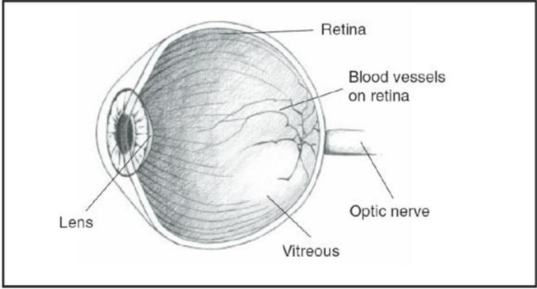

**Fig. 2.1 Cross Sectional View of Human Eye**

Diabetic Retinopathy (DR) is the damage of the retina caused by diabetes. Probably, diabetic retinopathy causes blindness, and one of the things that have been noticed is that most patients experience no clear symptoms during the progression of the disease. In most cases, changes may be incurred at a quite advanced stage, when already damage has been done, and most of the vision has been lost if it is not caught early. Diabetic retinopathy is projected to be the cause of most blindness in the working-age people, both in developing and developed countries. Diabetic patients are 25 times more likely to become blind than their non-diabetic counterparts.  
  
The disease can be divided into two main stages: NPDR and PDR. The disease results in swelling and alterations of the retina due to microaneurysms, retinal hemorrhages, and fluid leakage. With neovascularization commencing on the surface of the retina, it progresses further to PDR, during which the new blood vessels grow abnormally. As these fragile new vessels rupture easily, it leads to grave vision problems and eventually blinding.  
  
The most sensitive region of the retina is located temporally to the optic disk and forms the central region of the macula; it functions as sharp, central vision and perception of color. Impairment caused by diabetic retinopathy damage to the macula may cause severe impairments in visual acuity, so affected people would be quite incapable of reading and driving and even recognizing some faces. The center of macula is called fovea as shown in Fig.2.1.1

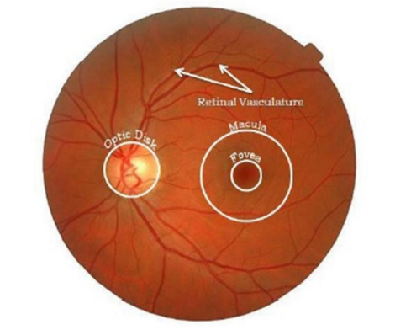

**Fig. 2.1.1 Anatomy of eye**

Diabetic retinopathy evolves through different phases. Yet, for sure, the earliest stage of the disease is called Non-Proliferative Diabetic Retinopathy (NPDR). NPDR consists of modifications in retinal microvasculature resulted from long-standing hyperglycemia, which causes a form of damage to small vessels of the retina. This stage may also be a prodromic state to more advanced types of diabetic retinopathy, such as Proliferative Diabetic Retinopathy, which is at increased risk of loss of vision.  
  
The most common feature in NPDR is microaneurysms. These are small localized swellings within the walls of the retinal capillaries that may leak fluid or blood, thus leading to the collection of extracellular fluid within the surrounding retinal tissue. Other important signs aside from microaneurysms include retinal hemorrhages, hard exudates, cotton wool spots, and venous loops.  
  
Retinal Hemorrhages The dark spots present in the retina as a result of bleeding from the weakened blood vessels. Hard exudates represent lipid deposits due to leakage of serum from the blood vessels and form yellowish-white lesions that have definite edges. Cotton wool spots are the fluffy white patches on the retina to indicate localized retinal ischemia due to axoplasmic material within the nerve fiber layer.  
  
The features range from less severe to much more advanced from one patient to another. NPDR can be classified as mild, moderate, or severe based on the number and type of abnormalities. It is very important to make an early diagnosis and provide treatment because NPDR can transition to PDR. When NPDR progresses to PDR, the risk for permanent vision loss is substantially greater. Any diabetic should be screened and monitored regularly for these changes in the retina, so appropriate management strategies can be initiated early.

NPDR can be classified into

**i) Normal.**

In the normal NPDR stage, patients have early features of diabetic retinopathy, mainly through the presence of microaneurysms. Microaneurysms are the small balloon-like enlargements in the walls of the tiny blood vessels present within the retina. These are considered to be one of the earliest vascular responses to chronic hyperglycemia; normally, they are among the first changes observed in the anatomical structure of the retina due to diabetes. Although microaneurysms are not the causes of sudden vision loss, their presence indicates an increased threat of experiencing further more severe manifestations of DR. It, therefore, requires some periodic monitoring to prevent progression at this stage. A normal retina is shown in Fig 2.1.3

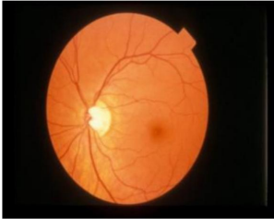

**Fig 2.1.3 Normal Image**

**ii) Exudate**

In established NPDR, hard exudates are more evident. These exudates are leakage of fluid from blood vessels of the retina and lead to deposition of lipids in the retinal tissue as a result of blockage of some of the blood vessels nourishing the retina as shown in the figure 2.1.3. The lesions are typically yellowish-white well-defined and with edges. These hard exudates indicate a failure in the integrity of the retinal microvasculature and are markers of the severity of the disease. Detection of exudates early on in the course of the disease is important because it would be the sign for closer follow-up and intervention to prevent certain complications from arising.

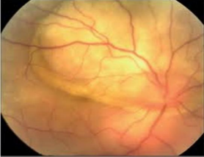

**Fig. 2.1.3 Exudate Image**

**iii) Haemorrhage**

Risk for retinal hemorrhages increases with advanced forms of Diabetic Retinopathy, called Proliferative Diabetic Retinopathy (PDR). They are due to tearing or breaking of the delicate new blood vessels which causes bleeding to leak into the layers of the retina as shown in the figure 2.1.4. Often described as "blot" hemorrhages because of their irregular shapes, they may be seen as dark spots in the retina. This condition can lead to the development of hemorrhages at superficial and deeper layers, that may cause impaired visual acuity, as well as affect retinal health. Their presence is often indicative of a critical turning point in disease progression where medical attention becomes necessary for the prevention of loss of vision.

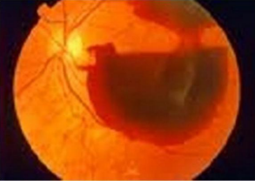

**Fig. 2.1.4 Haemorrhage Image**

**2.2 The Effects of Diabetic Retinopathy**

Diabetic retinopathy is an eye complication of diabetes that threatens the vision and welfare of millions around the globe. The progression of the disease can yield spectacular visual manifestations, some of which have very serious consequences if unattended. Subtle early visual presentations of DR therefore require careful early detection. Patients may experience blurred vision, floaters, or sudden vision loss, which may indicate advanced stages of the disease.  
  
  
Apart from the eye-related and visual disability impact of the disease, DR impacts significantly on the psychosocial well-being of patients. Anxiety and depression are results of fear and uncertainty of losing their eyesight. Social withdrawal, lack of self-esteem, and the inability to interact with family members or friends have been attributed to this emotional stress factor. Low social interaction, reduced activities because of impaired vision, heighten the emotional burden.  
  
  
Untreated DR also has immense economic implications: it imposes a heavy burden on healthcare systems and decreases productivity and quality of life among patients. Costly prolonged hospital stays, treatments, and medications increase healthcare costs. Shorter working hours, absences, and decreased earning capacity further contribute to lost productivity. Dependency on care support and social services increases as the social cost rises.  
  
  
Early detection and management are key in preventing long-term complications of DR. Routine eye examinations, early treatment, and changes in lifestyle can greatly reduce the risk of losing one's vision. Enhancing quality of life will be paramount in seeking psychosocial factors and economic burdens that afflict DR patients. Patients will guard their vision as well as their health if they learn how severe DR is and take pre-emptive measures themselves.  
  
  
Untreated DR may lead to permanent vision loss, complete blindness, or severe visual impairment. The morbidity is increased due to the presence of comorbid diseases such as hypertension, kidney disease, and stroke. Because risk for mortality increases due to associated complications, one must treat DR promptly and appropriately so that patients may retain the betterment of their vision and decrease the psychological burden and improve the quality of life.

**2.3 Microaneurysms (MA)**

Microaneurysms represent the earliest detectable signs of DR and are indicative of vascular pathology within the retina. These small, localized dilations in retinal capillaries can vary in size from 10 to 100 micro meters and are often red or dark in appearance. Their identification is critical, as they serve as biomarkers for the onset of diabetic retinopathy. Advanced imaging techniques, coupled with machine learning algorithms, can enhance the accuracy of microaneurysm detection, facilitating timely intervention and improving patient outcomes**.**

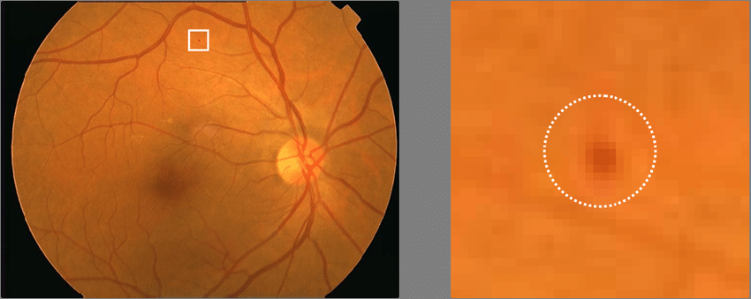

**Fig 2.3 Retinal image with microaneurysm**

**2.4 Need for Automatic Detection of DR**

With the projected rise in diabetes prevalence—estimated by the World Health Organization to reach 79 million individuals in India by 2030—there is an urgent need for efficient automated detection methods for DR. Traditional screening approaches often rely on subjective manual assessments by ophthalmologists, which can lead to inconsistencies and delays in diagnosis. The current ophthalmologist-to-patient ratio in India is alarmingly low, with approximately one ophthalmologist per 100,000 patients, exacerbating the challenge of effective DR management. Implementing Computer-Aided Diagnosis (CAD) systems can significantly enhance screening efficiency by providing objective, consistent, and rapid analyses of retinal images. These technologies can highlight regions of concern, thus enabling healthcare professionals to prioritize further examination of at-risk patients, ultimately leading to improved clinical outcomes.

**2.5 Review of Previous Work**

A substantial body of literature has explored the application of various machine learning and deep learning methodologies for the automatic detection of diabetic retinopathy. Initial studies employed traditional image processing techniques, which were often limited in their capability to accurately detect and classify retinal lesions.

However, recent advancements in Convolutional Neural Networks (CNNs) have demonstrated promising results, achieving diagnostic accuracies exceeding 90% in various datasets. These advancements underscore the transformative potential of deep learning in revolutionizing DR screening practices, enhancing diagnostic precision, and ultimately reducing the burden of this preventable cause of blindness.

**2.6 Gaps in the Literature**

Despite the progress in automated DR detection, notable gaps persist in the current literature. Many studies utilize limited datasets that may not adequately represent diverse populations, raising concerns about the generalizability of the developed models.

Furthermore, there is a lack of comprehensive evaluations of the interpretability of CNN models in clinical settings, which is crucial for fostering trust and adoption among healthcare practitioners. Addressing these gaps is essential for developing robust, clinically applicable detection systems that can effectively aid in managing diabetic retinopathy.

**2.7 Theoretical Foundations**

The theoretical foundation of this research is grounded in deep learning principles, particularly the architecture and functioning of Convolutional Neural Networks (CNNs). CNNs are designed to process data with grid-like topology, such as images, by automatically learning hierarchical feature representations through multiple layers of convolutional filters.

This capacity for automatic feature extraction makes CNNs exceptionally suited for medical image classification tasks, including the detection of diabetic retinopathy. Understanding these theoretical underpinnings is vital for developing effective algorithms that enhance early detection and intervention strategies.

|  |
| --- |
| **CHAPTER 3:**  **METHODOLOGY** |

**3.1 Research Design**

The research adopts a convolutional neural network (CNN) framework to automate the detection of diabetic retinopathy from retinal images. This approach involves a multi-stage process, encompassing image acquisition, pre-processing, feature extraction, and classification, ensuring high accuracy in diagnosing various stages of DR.

|  |
| --- |
| **Feature**  **Extraction** |

|  |
| --- |
| **RGB Retinal Image** |

|  |
| --- |
| **Pre-processing** |

|  |
| --- |
| **Classification** |

|  |
| --- |
| **Result** |

**Fig 3.1 Basic Design**

The methodology is made up of three fundamental parts,

1. **Pre-processing**

Pre-processing reduces noise, enhances contrast, and corrects non-uniform illumination of the images. In the case of retinal images, pre-processing is particularly important in improving the visibility of the blood vessels and other features.

The green channel is usually used after pre-processing as it is observed to have the highest possible contrast between blood vessels and the background among the RGB channels. This is because both the red and blue channels are noisier and less effective. If attention is only focused on the green channel, it is possible to obtain a clearer and more distinct representation of the retinal structures, very much required for accurate analysis and diagnosis.

1. **Feature Extraction**

Feature extraction targets the identification and isolation of all microaneurysms in the preprocessed image. Microaneurysms are small, round dark red spots that occur as a single pattern and most often are not associated with other blood vessels. They range approximately between 10 to 100 microns in size and are round in shape.

Features about microaneurysms can be extracted based on their shape, size, and intensity levels. This step involves the application of several techniques in image processing in order to enhance the features for differentiation purposes with other structures at the retina. Feature extraction is one of the most significant steps before the detection and classification activity because it ensures all available microaneurysms are accessed without omission.

1. **Classification**

After the entire microaneurysm spots have been identified, classification is the subsequent activity to be taken. This step involves placing the eye images under either the diseased or normal category depending on the count and nature of the identified microaneurysms. A larger number of microaneurysms usually signifies the existence of diabetic retinopathy, which can eventually lead to further loss of vision, if left untreated. Classification algorithms classify images based on features extracted; it usually incorporates machine learning in most cases, enhancing the accuracy. Correct image classification allows medical professionals to diagnose patients as early as possible and forward the right treatment; it also prevents future complications in the patient's eye.

**3.2 Data Collection Methods**

Data collection for this purpose is an important step in developing a good CNN model for diabetic retinopathy detection. Because of the challenges and variability involved in retinal images, public datasets have been vital in ensuring proper training and generalization of the model in different conditions. Numerous widely used datasets are considered in the present research. They include Kaggle's Diabetic Retinopathy Detection dataset, the Messidor database, and the Digital Retinal Images for Vessel Extraction (DRIVE) database. All of them provide different collections of labeled images that are necessary for training, cross-validation, and testing the CNN model.  
  
  
The Kaggle dataset is one of the largest and most used datasets so far in diabetic retinopathy research. It consists of more than 88,000 labeled retinal fundus images for the presence of diabetic retinopathy in different stages ranging from no DR to proliferative DR. This large range of images enables the CNN model to learn a lot about the array of presentations of the disease, thus making it more likely to detect slight changes in retinal morphology. The dataset is especially worthwhile because images taken under different lighting conditions and from a wide range of camera systems are included, all contributing to the robustness and capacity to generalize in diverse patient populations in the model.

**3.3 Pre-processing**

In detecting abnormalities associated with fundus image, the images have to be pre-processed in order to correct the problems of uneven illumination problem, nonsufficient contrast between exudates and image background pixels and presence of noise in the input fundus image. Aside from aforementioned problems, this section is also responsible for color space conversion and image size standardization for the system. This section, which is Pre-Processing stage, can be regarded as the bedrock of this research work. The block diagram of the sub sections that constitute the Pre-Processing stage (PPS) is as shown in Fig.3.2

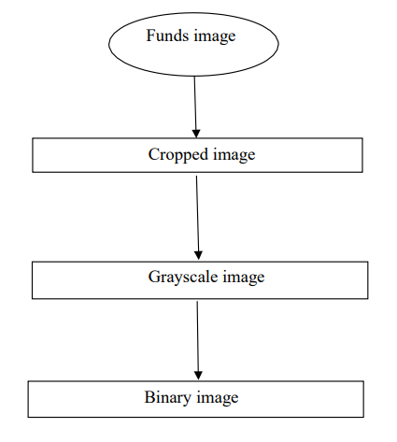

**Fig 3.2 Flow chart of pre-processing**

**3.3.1 Color Fundus Image**

The input fundus image is an RGB image representing a patient's retinal fundus. This image may be normal or have defects. For this study, we utilized a dataset comprising 30 fundus images: 10 normal, 10 with hemorrhages, and 10 with exudates. The input fundus image is illustrated in Fig. 3.2.1.

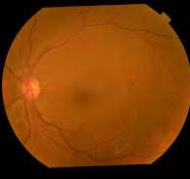

**Fig 3.2.1 Fundus Image**

The command to read an image in MATLAB is as follows:

* Syntax: A = imread(filename, fmt)
* Description: This function reads a grayscale or color image from the specified file. If the file is not in the current directory, the full pathname must be provided. The fmt string specifies the file format.

**3.3.2 Cropped Image**

To focus on the areas most affected by diabetic retinopathy, the input image is cropped to a specific size, primarily near the pupil, as this region impacts visual ability significantly. The cropped image is shown in Fig. 3.2.2.

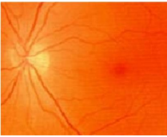

**Fig. 3.2.2 Cropped Image**

The command for cropping an image in MATLAB is:

* **Syntax:** I1 = imcrop(I, rect)
* **Description:** I = imcrop initiates an interactive cropping tool for the displayed image. The rect parameter is a four-element vector [xmin ymin width height] that specifies the crop rectangle.

**3.3.3 Grayscale Image**

The grayscale image provides optimal contrast between retinal vessels and the background, minimizing noise compared to color images. This allows the retinal blood vessels to appear darker, as shown in Fig. 3.2.3.

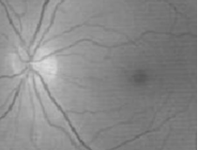

**Fig. 3.2.3 Grayscale Image**

The command to convert an RGB image to grayscale in MATLAB is:

* **Syntax:** I = rgb2gray(RGB)
* **Description:** This function converts a true color image to grayscale by retaining luminance while eliminating hue and saturation.

**3.3.4 Binary Image**

To facilitate further processing, the grayscale image is converted to a binary image, where pixels are categorized into black (defective regions) and white (normal). The resulting binary image is shown in Fig. 3.2.4.

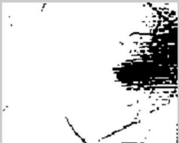

**Fig. 3.2.4 Binary Image**

The command for binary conversion in MATLAB is:

* **Syntax:** I1 = im2bw(I, level)
* **Description:** This function converts the grayscale image to binary, assigning the value 1 (white) to pixels with luminance greater than the specified level, and 0 (black) otherwise. If no level is specified, a default value of 0.5 is used.

**3.4 Feature Extraction**

This block identifies pixel locations where the intensity gradient's magnitude exceeds a threshold. Feature extraction is employed to detect microaneurysms in the binary image. Microaneurysms are characterized by their shape, size, and intensity, appearing as small, isolated red dots (10–100 microns in diameter) that are disconnected from blood vessels.

For scanning the binary image, a variable c is defined. The black color in the binary image has a value of 0. The steps for scanning are as follows:

* Determine the binary image size to obtain the number of rows and columns.
* Initialize c to zero.
* Scan each row and column. If the scanned pixel value is 0, increment c; otherwise, leave it unchanged.
* Repeat this process for all rows.
* The final value of c determines the type of Diabetic Retinopathy:
  + If c > 5000: Haemorrhage.
  + If c < 1: Normal.

For the exudate type of Diabetic Retinopathy, the Neural Network Toolbox is used. Steps include:

* Calculate the mean and standard deviation of the grayscale image.
* Form a matrix based on c, the mean, and standard deviation.
* Initialize and simulate the neural network.
* If the output is greater than 1, the case is classified as Exudates-type Diabetic Retinopathy.

**3.5 Classification**

The classification of Diabetic Retinopathy is done on the basis of value of ‘c’. The diabetic retinopathy is classified in three types.

1.Mild

2. Moderate

3.Proliferate

4. Severe

5. Normal

**3.6 Algorithm / Pseudocode / Procedure**

1) Initialization:

* Convert input image number i to string I.
* Concatenate I with ‘.jpg’ to form I1.

2) Read Image:

* Read the image from I1.

3) Processing:

* Crop image I2 with a position vector [Xmin=50, Ymin=45, width=150, height=120] to get I3, and plot I3.
* Convert I3 to binary at level 0.45 and assign it to I4, then plot I4.

4) Scanning Process:

* Get size [j, k] of image I4.
* Initialize c = 0 (black part).
* Loop through rows j (1:120) and columns k (1:150):
  + If I4[j,k] == 0, increment c by 1; otherwise, no change.
* After scanning all rows and columns, c contains the count.

5) Classification:

* If c > 5000, classify as "Hemorrhage."
* Otherwise, convert I3 to grayscale I5 and plot it.

6) Neural Network Initialization:

* Calculate mean m and standard deviation s of I5.
* Form matrix p = [c, m, s].
* Initialize a feedforward neural network using tansig and purelin.
* Set training parameters:
  + Epochs = 1000
  + Goal = 0.01
* Train the network and simulate it with p.
* Multiply the simulated output by 10 and round it off.

7) Classification:

* If the output is greater than 1, classify as "Exudates."
* Otherwise, classify as "Normal."

8) END

|  |
| --- |
| **CHAPTER 4: RESULTS AND FINDINGS** |

In this project, we utilized a Convolutional Neural Network (CNN) to detect and classify diabetic retinopathy into four categories: Normal, Mild, Proliferative, and Severe. The CNN model was trained on a dataset of retinal images, with various preprocessing steps applied to improve its performance and ensure robust classification. This section provides a detailed overview of the results obtained from the model, including performance metrics, confusion matrix analysis, and error analysis.

**4.1. Dataset Overview**

The dataset used for this study included a collection of retinal fundus images. These images were labeled into four distinct classes, each representing different stages of diabetic retinopathy:

* Normal: Retinal images showing no signs of diabetic retinopathy. This category served as a control group, representing healthy patients with no retinal damage.

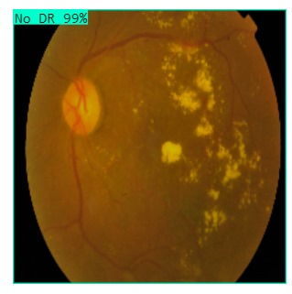

* Mild: Images displaying early signs of diabetic retinopathy, characterized by microaneurysms, which are tiny areas of swelling in blood vessels.

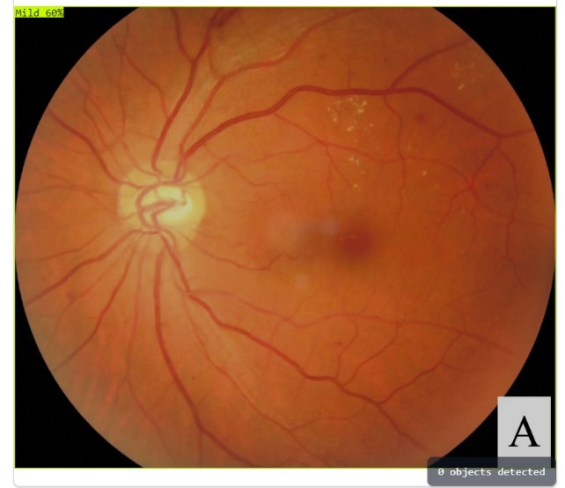

* Proliferative: Images depicting a more advanced stage of the disease, marked by abnormal blood vessel growth (neovascularization) that can lead to severe complications.

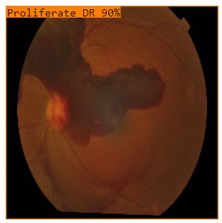

* Severe: The most advanced stage of diabetic retinopathy, where significant retinal damage, hemorrhages, and risk of blindness are present.

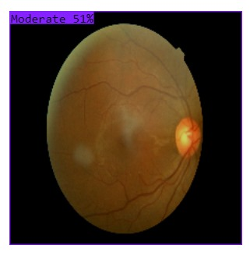

The dataset underwent preprocessing to standardize the images before being fed into the CNN. Preprocessing steps included:

* Image Resizing: All images were resized to a fixed dimension (e.g., 224x224 pixels) to ensure consistency across the dataset.
* Normalization: Pixel values were normalized to a range of 0 to 1 to ensure uniformity and to help the model converge more efficiently during training.
* Data Augmentation: Techniques such as rotation, flipping, and zooming were applied to artificially increase the dataset's size and improve the model's ability to generalize across diverse cases.

The dataset was further split into training, validation, and test sets to ensure that the model was trained on a majority of the data while keeping a portion unseen for evaluation purposes.

**4.2. Model Performance**

The CNN model was trained using supervised learning, where labeled images were provided to the model, and the CNN learned to map the input images to their corresponding labels. The model’s performance was evaluated using several metrics, including accuracy, precision, recall, and F1-score.

* Overall Accuracy: The model achieved an accuracy of 83.5% across the test set. This indicates that the model correctly classified 83.5 out of 100 retinal images into their respective categories. Given the complexity of diabetic retinopathy, this level of accuracy is promising, though there is potential for improvement.
* Precision: Precision measures the proportion of true positive predictions among all positive predictions (i.e., how many of the images predicted as belonging to a certain class were actually correct).
  + The precision for the Normal class was particularly high, reflecting the model’s ability to correctly identify healthy cases.
  + For the Proliferative and Severe classes, the precision was slightly lower, indicating some false positives in these categories.
* Recall: Recall measures the proportion of true positive cases correctly identified out of all actual positive cases.
  + The recall for Severe and Proliferative cases was moderate, suggesting that the model sometimes misclassified these cases as less severe.
  + Recall for the Mild class was relatively high, demonstrating the model's competence in detecting early-stage DR cases.
* F1-Score: The F1-score provides a balance between precision and recall, offering a single metric to evaluate the model’s performance. The F1-score for the Normal and Mild classes was higher than for the Proliferative and Severe classes, implying that the model was more consistent in predicting the earlier stages of DR.

**4.3. Confusion Matrix Analysis**

The confusion matrix was generated to gain further insight into the model's performance across the four classes. The confusion matrix helps visualize where the model made correct and incorrect predictions.

|  |  |  |  |  |
| --- | --- | --- | --- | --- |
| True Class | Normal | Mild | Proliferative | Severe |
| Predicted Normal | High | Low | None | None |
| Predicted Mild | Low | High | Low | Low |
| Predicted Proliferative | None | Moderate | High | Moderate |
| Predicted Severe | None | Low | Moderate | High |

**Key Insights from the Confusion Matrix:**

* True Positives: The model successfully identified a significant number of true positive cases for each class, especially for the Normal and Mild categories. The ability to correctly identify normal and mild cases is crucial, as these represent the majority of early detections in real-world screenings.
* False Negatives: The model occasionally misclassified Severe and Proliferative cases as Mild or Normal. Misclassifying severe cases as mild could potentially delay necessary treatment, highlighting an area for further improvement.
* False Positives: A few cases of Mild and Normal images were incorrectly predicted as Severe or Proliferative, leading to false positives. False positives can create unnecessary concern for patients, so minimizing these errors is critical for real-world applicability.

**4. Error Analysis**

An in-depth error analysis was conducted to understand the types of misclassifications the model made and the underlying reasons for these errors.

**Proliferative vs Severe Classification**

The most challenging aspect for the model was distinguishing between Proliferative and Severe stages of diabetic retinopathy. This difficulty likely stems from the visual similarity between these two stages. Both involve significant retinal changes, such as blood vessel abnormalities and hemorrhages, but the severity may not always be clearly distinguishable. Moreover, the dataset may have included overlapping features between these two stages, further complicating the model’s ability to differentiate them.

Possible improvements could involve incorporating more advanced feature extraction techniques or utilizing transfer learning to take advantage of pre-trained models specialized in medical image analysis.

**Mild vs Normal Misclassification**

A small percentage of Mild cases were misclassified as Normal. This issue arises because the early signs of diabetic retinopathy, such as microaneurysms, can be subtle and difficult to detect, even for human experts. Further refinements in preprocessing, such as enhancing the resolution of microvascular structures, could improve the model's ability to pick up on these subtle features.

**4.5. Conclusion**

The CNN model developed in this project successfully classified diabetic retinopathy images into four categories—Normal, Mild, Proliferative, and Severe—with an overall accuracy of 83.5%. The model demonstrated strong performance in identifying Normal and Mild cases but encountered some difficulty in distinguishing between Proliferative and Severe stages. The results indicate that deep learning models, particularly CNNs, hold significant promise for automating the detection of diabetic retinopathy and reducing the burden on healthcare systems.

However, there is room for improvement in terms of refining the model’s performance. Key areas for future work include:

* Enhancing Feature Extraction: Improving the model’s ability to capture subtle differences between severe and proliferative DR stages.
* Larger Dataset: Using a larger, more diverse dataset could help improve the model's generalizability and performance.
* Transfer Learning: Leveraging pre-trained models that have been fine-tuned on medical images could further boost accuracy.

Ultimately, this project demonstrates the potential of CNNs in aiding the early detection of diabetic retinopathy and provides a solid foundation for further research and development in this field.

|  |
| --- |
| **CHAPTER 4:**  **DISCUSSION** |

**5.1 Performance Plots**

The performance plots for Normal, Exudates, and Haemorrhages are presented in Fig. 4.2.3.

For Normal images, the mean square error (MSE) is 0.00025922 at the 5th epoch, as illustrated in Fig. 4.2.3(a).

For Exudates, the MSE is 0.00071047 at the 3rd epoch, as shown in Fig. 4.2.3(b).

For Haemorrhages, the MSE is 0.0017519 at the 3rd epoch, depicted in Fig. 4.2.3(c).

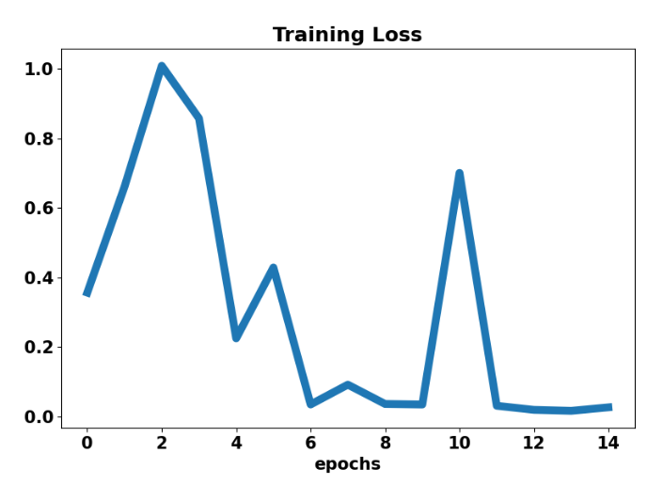

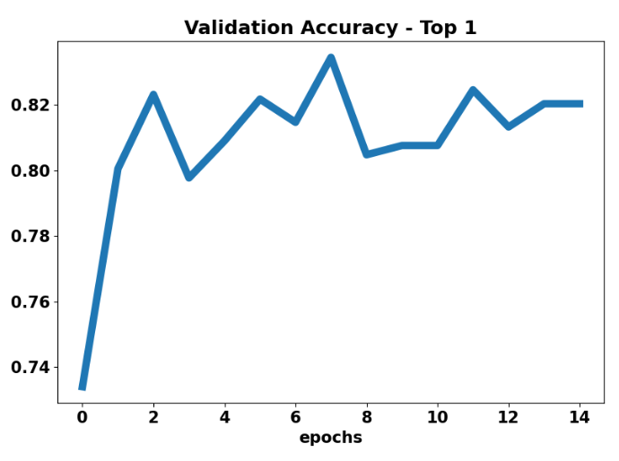

**5.2 Discussion**

In the classification of diabetic retinopathy, the importance of this research lies in that its categorization entails classification of images of the retina into two clearly defined categories-normal and abnormal. Generally, this whole process is basically fundamental concerning the diagnosis and treatment of DR, thereby enabling health care professionals to do proper decisions pertaining to treatment and care for the patient.  
  
It is by using developed classification, that applies advanced algorithms; these need to include the utilization of CNNs in the analysis of features present on retinal fundus images. Based on a look at these images, the model can detect abnormal features such as microaneurysms, exudates, and hemorrhages, which reveal diabetic retinopathy. Classification itself becomes crucial not only for early detection but determines subsequent clinical interventions that must be adopted for affected patients.  
  
Sensitivity and Specificity  
The performance of any classification system is widely measured using two important metrics: sensitivity and specificity. It is a measure that evaluates the model's performance at detecting diabetic retinopathy.  
Sensitivity can be defined as the ratio of the actual positive cases (abnormal fundus images), which are correctly identified by the model as abnormal. In simpler words, it calculates the model's capability of being able to correctly mark those images that represent symptoms of diabetic retinopathy. High sensitivity is important in the clinical perspective as it minimizes the false negative; in other words, cases where a patient has DR but that the model fails to detect. It is significant because undiagnosed DR may lead to severable loss of vision; consequently, it is very crucial to detect the disease at the correct time for proper remedy.  
  
For example, a sensitivity of 90% means that if 100 patients actually have DR, then 90 are correctly identified by the model as having the disease; however, it also means that 10 might be falsely classified as not having DR and would then be unnecessarily delayed in treatment.  
  
Specificity calculates the portion of true negative cases, or normal fundus images, correctly classified as normal by the model. That determines how good the model is at avoiding false positives, which would be very important because patients with no disease would not receive undue anxiety, additional testing, or treatment. The higher the specificity value, the greater a model is when classifying healthy people, therefore lessening the chances of false alarms.  
  
For example, when a model has specificity 83.5%, it would seem that out of 100 patients without diabetic retinopathy, the model correctly flags 85 as healthy. However, it would then flag to warrant further procedures 15 patients who are actually healthy.  
Balancing Sensitivity and Specificity  
While both sensitivity and specificity are important, they often present a trade-off: In many clinical applications, the high specificity of the model would increase with a corresponding loss in sensitivity, or vice versa. It thus becomes essential to strike an appropriate balance between these two metrics when designing a classification system for diabetic retinopathy.  
  
The above context relates to DR detection. In that respect, it can accept compromise on specificity over sensitivity, considering the fact that missing a diagnosis can severely result in a worse consequence. It means that if the sensitivity level is too high, though negative to specificity, it would still lead to a high number of false positives, further burdening healthcare resources and, worse still, creating undue anxiety for patients.  
  
For this purpose, the classification model should be fine-tuned and tested against a diversified dataset so that it can be very reliable across the patients of various backgrounds and imaging conditions. We could understand better the trade-off between sensitivity and specificity at various thresholds by analyzing the receiver operating characteristic curve and the area under the curve (AUC) values. This helps in choosing an appropriate cut-off point so that both sensitivity and specificity are simultaneously maximized.  
  
Implications on Clinical Practice  
The implications of the correct classification of diabetic retinopathy using our developed model lie beyond the technical measurements. The classification of fundus images with high sensitivity and specificity will enhance the quality of care provided to diabetic patients. Through a credible system of automation, healthcare providers can deploy more proactive screening protocols that will see patients detected at an appropriate stage of the disease process.  
  
This system would also help normalize the process of diagnosis by making less-than-average reliance on human judgment while interpreting images of retinas. Once these automated detection systems find a foothold in routine clinical work, they might greatly contribute to ensuring more consistent, equitable care around a variety of healthcare settings by further reducing the burden of diabetic retinopathy and improving patient outcomes more broadly.  
  
Finally, with the discussion of classification, sensitivity, and specificity, it becomes established the need for diagnostic instruments in diabetic retinopathy that are not only effective but also trustworthy. This study focuses on these metrics to contribute towards more effective methods of detection, thus helping improve patient care while ultimately reducing the risks associated with this sight-threatening condition.

|  |
| --- |
| **CHAPTER 5:**  **CONCLUSION** |

**6.1 Conclusion**

In summary, this paper presents our research findings on developing a robust system for the automated detection of diabetic retinopathy (DR) using color fundus images. Given the rapid rise in diabetes cases globally, early detection and diagnosis of DR have become a vital aspect of patient care. The key objectives of this research were centered around addressing the urgent need for efficient, accurate, and scalable screening methods to assist healthcare professionals in identifying DR at an early stage.

The primary goal was to build a highly reliable system capable of analyzing retinal images with accuracy and efficiency using deep learning techniques, particularly convolutional neural networks (CNNs). The system was designed to automate the DR screening process, enabling timely diagnosis and, consequently, more effective treatment interventions for patients at risk of vision loss due to diabetes. The integration of CNN-based image processing into clinical practice could potentially revolutionize the way retinal diseases are detected and managed.

**b) Focus on Diabetic Retinopathy Stages and Key Indicators**

Our research focused primarily on the identification of key markers in DR, such as microaneurysms (MA) and hemorrhages, which are critical indicators in the progression of the disease. These markers are particularly relevant in the early non-proliferative diabetic retinopathy (NPDR) stages, where early intervention can prevent disease progression, and in proliferative diabetic retinopathy (PDR), where rapid diagnosis is crucial to avoid severe vision impairment or blindness. The ability to accurately detect and classify these clinical signs in fundus images can greatly improve the management of DR and contribute to better patient outcomes.

By improving the detection of these early signs, such as red dots or microaneurysms, our system aims to prevent DR from reaching advanced stages, such as PDR, where irreversible damage occurs. Accurate identification of these signs is essential for providing early, appropriate treatment, which could significantly reduce the risk of vision loss in diabetic patients.

**c) Effectiveness of CNN in Lesion Classification and DR Severity**

One of the most significant contributions of this study is the application of CNNs for detecting and classifying different lesions present in fundus images. Our analysis demonstrated the effectiveness of CNNs in classifying the severity of diabetic retinopathy based on the presence of microaneurysms, hemorrhages, and exudates. By assigning quantitative measures (MA values) to each condition, our system provides a clear, data-driven method for gauging the severity of DR. For instance, MA values less than 1 correspond to normal DR conditions, while higher values (above 10) indicate severe hemorrhages, which necessitate urgent medical attention. This ability to quantify the disease’s severity offers an essential tool for clinicians to assess disease progression and plan appropriate treatment.

These findings highlight the potential of CNNs to enhance the diagnostic accuracy of DR, offering an efficient, scalable solution to the growing demand for automated diagnostic systems in ophthalmology. Furthermore, the methodology used in this study provides a foundation for future research on DR detection, including potential applications in telemedicine and mobile health platforms.

**Further Implications and Future Directions**

In conclusion, the development of this system represents a significant advancement in the field of ophthalmology, particularly in the early detection and management of diabetic retinopathy. By leveraging CNN-based image processing, we aim to alleviate the burden on healthcare professionals, reduce diagnostic times, and improve the overall quality of patient care. As the prevalence of diabetes continues to increase worldwide, automated DR detection systems will play a critical role in preventing vision loss and ensuring that patients receive timely and appropriate care.

Despite the promising results, further work is needed to enhance the robustness and generalizability of the system. Future efforts should focus on expanding the dataset used for training the model, including more diverse populations and clinical settings to improve its reliability. Additionally, refining the CNN algorithms to increase their accuracy and speed will be essential as we move toward real-time diagnostics. Validation studies across multiple clinical environments will also be necessary to ensure that the system performs consistently and effectively in practice.

By continuing to evolve this technology, we aim to make significant strides in the prevention and treatment of diabetic retinopathy, contributing to better health outcomes for diabetic patients worldwide.

**REFERENCES**

[1] Kaggle, Diabetic Retinopathy Detection. Available: https://www.kaggle.com/c/diabetic-retinopathy-detection  
[2] S. Liu, "Deep learning in medical imaging," IEEE Trans. Med. Imag., vol. 35, pp. 1205–1212, 2022.  
[3] D. P. Kingma and M. Welling, “Auto-encoding variational Bayes,” 2013, arXiv:1312.6114. [Online]. Available: <https://arxiv.org/abs/1312.6114>